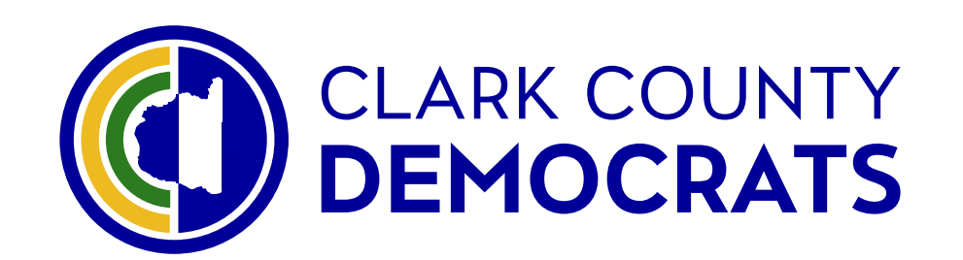
Executive Board Meeting Minutes
April 15, 2024, 7-8:00 PM
Online via Zoom

- Call to order- 7:00pm
- Seek motion to approve of this agenda and the prior minutes. Moved by Alysia I. Privrat, seconded by Emily Borden. Passed by unanimous consent.
- Consider regular agenda item at General Meetings for candidate requests
- Training is available for those seeking training in voter contact with the Glusenkamp-Perez campaign.
- Emma Montague from the coordinated campaign will be coordinating activities
- There will be 4 field organizers as of June. They are looking for candidates. Job posted on Website.
- Pamphlet to be created with the CCDCC platform to be available at tabling events. Will be available in multiple languages. Motion to approve up to $2,500 for production and printing costs for a trifold and or single about the party platform. Motioned by Teri Niles, seconded by Hector Hinojosa. Moved by unanimous consent
- Dues to be paid to dues paying organizations including the Sierra Club, Chamber of Commerce, NAACP etc.. Motioned by Teri Niles, seconded by Leah Perkel. Moved by unanimous consent
- Please make a “What We Stand For” video
- The Four Fundamentals
- Consistent Messaging: Now that we have a new Unity Platform, let’s put it to use!
(See attachment)
- Win With 10! Update and Next Steps
(See attachment)
  - Heidi Stegman is social medial and volunteer coordinator, she will be at the office on Wednesday evenings at the office.
- Ogden Dinner: Saturday, August 24, 5-9 PM, Vancouver Hilton, Featuring Lt. Gov. Denny Heck as MC and keynotes by Rep. Marie Gluesenkamp Perez, Lt. Gov. Bob Ferguson, and Sen. Maria Cantwell confirmed.
  - Will be at the Hilton in downtown Vancouver.
- Sustaining donors: Update and Next Steps
- Old Business
- Come to the Forward Friday!
- Community liaison function: We now have nametag-sized badges for community liaisons. Some are just the logo and “Clark County Democrats” (like the sign outside our office), and others have that and also say “Community Liaison.” We need someone to lead the Community Liaison function, including: keep track of who our liaison is for each group is (eg, LULAC, NAACP, Labor Round Table, Sierra Club, etc.); ask them to be sure to attend regularly; wear the badge identifying themselves as our liaison; listen and be a good ally; and build positive relationships.

- New Business
- None this month, except as already addressed above
- Announcements and good of the order
  - Denny Heck’s Anniversary and Fundraiser event is this Wednesday
  - Start thinking about volunteering at the Clark County Fair and organizing the candidates

- Meeting adjourned 8:40pm

ATTACHMENT A
Full list of measurable goals
- LD17 adding 4,000 democratic votes above current base
- LD18 adding 5,000 democratic votes above current base
- LD49 adding 3,710 democratic votes above current base
- Recruit 100 Voter Contact Volunteers
- Double number of PCOs (from 65 on January 1 to 130 by Dec 31)
- 100% of PCOs and VCVs actively conducting voter outreach (or for PCOs, alternative work of their choice)
- Sustaining donors drive exceeding $2500 per month (current baseline $1800)
- Ogden Dinner raising $26,000 (net) and stabilized as an ongoing system from year to year

_________________________________________________________________________________

ATTACHMENT B

Full Zoom Instructions

Clark County Democrats is inviting you to a scheduled Zoom meeting.

Topic: Clark County Democrats' EBoard Zoom Meeting
Time: This is a recurring meeting Meet anytime

Join Zoom Meeting
https://us02web.zoom.us/j/82999454882?pwd=czdPUElKSEs3WEFISGl5OHhoOGVlQT09

Meeting ID: 829 9945 4882
Passcode: 907857

---

One tap mobile
+12532050468,,82999454882#,,,,*907857# US
+12532158782,,82999454882#,,,,*907857# US (Tacoma)

---

Dial by your location
• +1 253 205 0468 US
• +1 253 215 8782 US (Tacoma)
• +1 669 900 6833 US (San Jose)
• +1 719 359 4580 US
• +1 346 248 7799 US (Houston)
• +1 669 444 9171 US
• +1 646 931 3860 US
• +1 689 278 1000 US
• +1 929 205 6099 US (New York)
• +1 301 715 8592 US (Washington DC)
• +1 305 224 1968 US
• +1 309 205 3325 US
• +1 312 626 6799 US (Chicago)
• +1 360 209 5623 US
• +1 386 347 5053 US
• +1 507 473 4847 US
• +1 564 217 2000 US

Meeting ID: 829 9945 4882
Passcode: 907857

Find your local number: https://us02web.zoom.us/u/kbetdBI3FE

